GitHub
https://docs.github.com/en/actions/learn-github-actions/understanding-github-actions
- GitHub Actions is a continuous integration and continuous delivery (CI/CD) platform that allows you to automate your build, test, and deployment pipeline.
-Can create workflows that build and test every pull request to your repository, or deploy merged pull requests to production.

Components of github actions
-Can configure a GitHub Actions workflow to be triggered when an event occurs in your repository, such as a pull request being opened or an issue being created.
-Workflow contains one or more jobs which can run in sequential order or in parallel.
-Each job will run inside its own virtual machine runner or inside a container, and has one or more steps that either run a script that you define or run an action, which is a reusable extension that can simplify your workflow
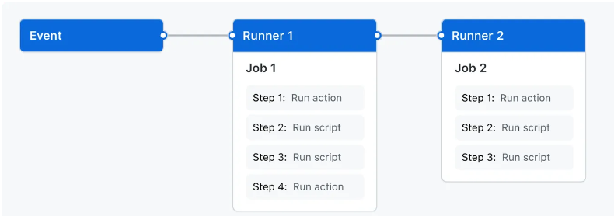
1. Events
-An event is a specific activity in a repository that triggers a workflow run.
-Each workflow should have atleast one job.
-An event can be a pull request, opens/created/closed an issue, or pushes a commit to a repository. You can also trigger a workflow to run on a schedule, by posting to a REST API, or manually.
2. Jobs
-A job is a set of steps in a workflow that is executed on the same runner.
-Each step is either a shell script that will be executed, or an action that will be run. Steps are executed in order and are dependent on each other.
-Since each step is executed on the same runner, you can share data from one step to another.
-By default, jobs have no dependencies and run in parallel with each other. When a job takes a dependency on another job, it will wait for the dependent job to complete before it can run.
3. Actions
-An action is a custom application for the GitHub Actions platform that performs a complex but frequently repeated task.
-Actions help to reduce the amount of repetitive code that you write in your workflow files.
-An action can pull your git repository from GitHub, set up the correct toolchain for your build environment, or set up the authentication to your cloud provider.
-Can write own actions, or you can find actions to use in your workflows in the GitHub Marketplace.
https://docs.github.com/en/actions/creating-actions
4. Runners
-A runner is a server that runs your workflows when they're triggered.
-Each runner can run a single job at a time.
-If a different operating system or require a specific hardware configuration, you can host your own runners. In multi runner configuration, we can specify the runner in which the jib has to be run.

Create a workflow
-GitHub Actions uses YAML syntax to define the workflow. Each workflow is stored as a separate YAML file in your code repository, in a directory named .github/workflows
-Create .github directory first
name: Optional - The name of the workflow
run-name: Optional - The name for workflow runs generated from the workflow
on: Specifies the trigger for this workflow. It can be push, pull_request (can specify the branch version also), workflow_dispatch, issues
jobs: Groups together all the jobs that run in the learn-github-actions workflow.
check-bats-version:Defines a job named check-bats-version. The child keys will define properties of the job.
runs-on: Configures the job to run on with the version (eg: ubuntu-latest)
steps: Groups together all the steps that run in the check-bats-version job. Each item nested under this section is a separate action or shell script.
- uses: actions/checkout@v3 --> here v3 is the version. @ is used to mention git references such as tags, commit, branch.
- uses: actions/setup-node@v3
with:
node-version: '14'
- run: npm install -g bats --> The run keyword tells the job to execute a command on the runner.
- run: bats -v
-Once the workflow is created, push it to the git
-The below pic shows how the workflow file will create and github components are organized in hierarchy.
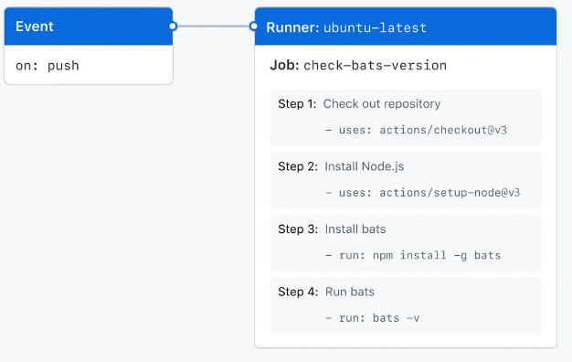
-Once it is pushed, we can verify it in the actions tab in github

To download the logs of a run,
-Select the required run – setting symbol – download log archive

